SW Engineering CSC648/848 2020

Project: Remedium

TEAM 4

Spencer Heltsley - [sheltsle@mail.sfsu.edu](mailto:sheltsle@mail.sfsu.edu)

Kevin Chan

Zi Collin Zhen

Kolapo Agunbiade

Andrew Keelin

Milestone 2

October 20th, 2020

M1 Submitted: October 2nd, 2020

M1 Revised Submitted: October 13th, 2020

***1. Data Definitions v2***

*Example Entry - (Note: Some of these data points may be rearranged, added, or subtracted from as the project goes forward, to increase organization, functionality, and usability. Such changes will be notarized and explained when they occur.)*

* **Example name:** Example description
  + Example of sub-data item and description
* **Unregistered User:** This type of user can only view the landing page or sign up.
  + Contains no data points - this is the default state if not logged in
* **Registered User:** A user that falls under the category of Physical Therapist, Patient. Registered users have a username and password to access their profile.
  + First + Last Name: Used for Identification for all registered users
  + Email: Used as a form of username, to login, and also for communication
  + Password: Secondary login credential, should be encrypted
  + Bio: Customizable per profile, used to give additional data
  + Registration Date: Date (serverside) that the user registered their account
  + Pings: All alerts the user should be aware of
  + Profile: Defined below, each user should have exactly one profile
* **Physical Therapist (PT):** A type of registered user that has a list of current patients, possible patients, and can send routines to and generate reports on those patients.
  + PTID: key identifier for the PT to enable easy database management and patient searching
* **Patient:** A type of user that can view a list of Physical Therapists, view their profile, keep a collection of possible PT’s they are interested in for later reference, upload videos. NOTE: All patients should be searchable in the backend through a structure sorting them by their PT, reducing the need for complicating tables. This is subject to change.
  + Patient ID: an identifier for patients to enable simpler searching and assigning via numeration
  + ptID: An identifier that explains which PT(s) this patient is assigned to. Currently one, but could be expanded to an array of PT’s if multiple are required
* **Report:** A system of tracked variables generated when a PT account interacts with a Patient account. These variables should be available upon request, and should be generated automatically without user input needed to begin.
  + Frequency: How often certain indexed activities recurred over the time period
  + Activities: All eligible actions that the PT performed upon the Patient account during the report’s time period
  + Activity Start/End: The date and time that each activity begun and end.
  + Total Time: The total length of time that the PT spent assisting the Patient
  + PatientID: The Patient (searchable in DB) that the Report is associated to.
* **Profile:** A page generated automatically, but customizable, for each Registered User. Serves as a place for information about the user to be displayed (such as the bio information), as well as to facilitate User to User communication, and a content repository.
  + Bio: Customizable Element that any registered user should be able to write themselves, to personalize their profile or give out more information.
* **Content Repository:** A receptacle for all content posts that have been uploaded by, or sent to a registered user. Videos in this may be public (if posted by a PT account) or private (default).
* **Body Diagram:** A customizable structure that can be designed along with any post, that should be able to highlight in detail where each exercise is to be targeting or ‘felt’ on the body. A number of these should be created and linked to based on the body parts selected. Specific Data members for each part of the body include:
  + Ankle, knee, back, shoulder, elbow, wrist (mandatory)
  + upper/lower arm, glute, thigh, calves, neck, core, chest (possibly)
  + Model ID is also required, for searchability and possibly embedding onto Posts
* **Content Post (Post):** A bit of information that a registered user wants to upload that has certain priorities and qualities to it based on who the user wants to see it. Generally, a PT will have more access to this feature than a Patient. Posts should be viewable based on options, tagged, composable, and searchable within a given Content Repository.
  + Text Description: mandatory part of each post, an explanation should be given to allow further explanation of what should be there. It is our view that no video could be properly helpful without associated text.
  + Video(s): (Optional) Should be uploaded into a standardized .mp4 format, with a maximum size per video of around 5 minutes.
  + Body Model: (Optional) Defined above.
  + Tags: Mandatory, some should be auto generated. Allows for easy searchability of posts within a Content Repository.
* **Database:** Our backend data; should contain all hidden details and be linked to the profiles, their permissions, their content repositories, and their account information such as passwords, etc. (Note: This is present to differentiate the Database from the Content Repository. The Database should contain all Content Repositories, but the Repositories are not the Database itself.)
* **Ping:** A type of alert or notification sent to a user on a fixed point within their profile, indicating new information or updates are available at a glance. (An example of a service providing a ping might be a new report, a new content post uploaded from a PT or patient tied to the account, or a new message)
  + Recipient - who the ping is for (should be an ID)
  + RelevantContent - what the ping should link to when clicked
  + Description - to be displayed to the user describing the ping
  + Position - where in the list of all pings this ping is located.
* **Tag:** A piece of information that can be tied to an exercise or post, that will be used to refine search results on searchable things. Can be auto-generated or customized.
* **Exercise Plan:** A specific type of content post that can be constructed by a PT User, and sent to a Patient. Exercise Plans should be able to be constructed and edited together similar to other content posts, with drag-and-drop content sendable to Recipients. Should also be saveable, and customizable.
  + Plan ID: for searchability and quick calling
  + Plan Name: For labeling and description
  + Description: To enable the PT to direct the patient in more specific or at-a-glance terms.
  + Patient ID: who the ping is to be sent to (who should receive the plan)
  + Video ID: List of videos embedded within the Exercise Plan
* **Category:** Denotes the type of post being viewed. (May be used to contain tags and used for search results as well, unsure yet)
  + Category ID: Lists a given category for easy organization
  + Category Name: In case needed for search results/tag generation

***2. Functional Requirements v2***

*Sorted by Priority and Category - Sub-requirements are listed below each category requirement and may not share the same priority, but will never exceed parent priority.*

**1. Profile Creation:** Physical Therapists should be able to create a profile using the general information they want to be publicly available on the website about their practice.

Priority: 1

**1.1 -** Profiles should be discernable on registration between PT and Patient accounts.

Priority: 1

**1.2 -** PT profiles should be able to decide if they want to import public Content Repositories to their own, to use generic exercises the website creators upload.

Priority: 3

**2. View Current Patients and their Profiles:** PT Profiles should be able to see a list of all of their patients, and access their profiles / assign them exercises if need be.

Priority: 1

**2.1 -** PT can see a list of patients linking to their profiles. Priority: 1

**2.2 -** PT can assign exercises to patients, pinging them and showing the exercise in their content repository.. Priority: 1

**2.3 -** Patients should be able to create similar lists of PT’s they’re interested in working with in the future, without necessarily pinging the PT. Priority: 3

**3. Upload Video:** PT’s should be able to upload a video tutorial for custom exercises towards ankles, knees, hips, back, shoulders, elbows, and wrists (to be used as tags) and called as a library.

Priority: 1

**3.1 -** Tutorials are uploadable to the Content Repository for that profile. Priority: 1

**3.2 -** Such posts should be able to be set public or privately viewable. Priority: 2

**3.3 -** Such posts should be accompanied with body models. Priority: 2

**3.4 -** Such posts should be accompanied with text descriptions. Priority: 2

**5. Pick Exercises from Preset Library:** PT should be able to upload exercises to their content repository to enable a drag and drop method of exercise creation, allowing exercises to be re-used for other patients, and allowing for easily and quickly customizable exercise plans.

Priority: 1

**5.1 -** Drag and drop exercise creation on a dedicated page. Priority: 1

**5.2 -** Reusable exercises and routines. Priority: 1

**5.3 -** Creation of Exercises should allow for multiple videos and body diagrams to be embedded, increasing functionality. Priority: 2

**8. Care Tracking:** Each patient profile should include an indicator as to how many minutes the PT has spent providing care to that patient. Eligible activities are:

Responding to questions

Reading Chat

Viewing Videos

Reading Profile

Generating Exercises

Reviewing Exercises

Priority: 1

**8.1 -** Eligible Activities increase timer when performed, and on their cancelation, send info back to the user’s report to be updated. Should not ping, merely update. Priority: 1

**9. Report Generation:** PT activity should be documented in a report, retrievable on request on a daily, weekly, and monthly basis, exportable into a PDF and including time tracking.

Priority: 1

**9.1 -** Reports should be viewable at any time by all PT and Patients by checking their listing on profile. Priority: 1

**9.2 -** Reports should be, by default, automatically sent to patient’s registered email accounts on a monthly basis. Priority: 1

**9.3 -** Report auto-generation should be able to be manually switched off. Priority: 3

**15. Notifications/Ping Queue:** A readied tab on each profile should display how many incoming patient apps are available, as well as how many messages are waiting to be answered in their respective tabs on the PT’s profile, or notifications of new posts/reports being available. Should be a general page listing all relevant updates for a user at a glance.

Priority: 1

**15.1 -** Creation of and delivery of pings of any kind, independent of type. Priority: 1

**15.2 -** Pings should have specific types, and should be sorted based on those types. Priority: 2

**15.3 -** Pings should be able to be switched on and off, with warning messages if all are switched off. Priority: 3

**15.4 -** Pings should have customizable delivery times. (En masse on the hour, per day, etc.) Priority: 3

**4. Upload Text/Modeled Videos:** Should be able to upload text along with videos, to explain further details if needed, or general information at a glance.

Priority: 2

**4.1 -** Text should be uploadable with videos. Priority: 2

**4.2 -** Videos should be accompanied by custom body diagrams. Priority: 2

**4.3 -** PT should be able to draw on videos if necessary, and quickly return the edits to sender for quick feedback. Priority: 2

**6. Review Patient Progress:** PT should be notified when patient uploads a video, and these videos should be editable by the PT with linework that can be drawn on top manually, give feedback to the patients beyond this, and even share these videos with other PT’s via enabling access to their content repositories.

Priority: 2

**6.1 -** Creation and Delivery of Pings on Content Repository updates. Priority: 2

**6.2 -** Customizable Pings, to allow for upload pings to be delivered all at once at a certain time of day/night. Priority: 3

**7. Text Communication:** A messaging system should be enabled between PT’s and patients, resulting in email and app-based Pings when messages are received, customizable to the account’s ping systems.

Priority: 2

**7.1 -** Text communication between Patients and PT accounts functional and send pings.. Priority: 2

**10. Forum Style Layout:** Posts and Videos, generally all content is structured around a forum-esque layout in the Content Repository, in which users can filter by post type, search for specific content uploaded by the PT, and generally access all content that the PT has uploaded to their account’s content repository. Additional functionality will be provided to privatize, update, delete, or filter posts. Should assist in ease of use.

Priority: 2

**10.1 -** Content repository should be searchable and layered in a way that posts are distinct, and obvious as to their content. Priority: 2.

**10.2 -** Posts should be listable as public, enabling other patients to see the video, enabling, for example, pure text-posts to be published as a means of quickly communicating with, and talking to all patients at once. Priority: 2

**10.3 -** Filters should be based on the tags of the videos uploaded. Priority: 3

**10.4 -** Comments on public posts. Priority: 3

**11. Profile Customization:** Most things on the profile (from picture, to description, to hours and other information) should be customizable and editable by the PT at any time. These customizations should not be in such a way that they detract from the overall look and feel of the site, but should give each profile a bit of personality.

Priority: 2

**11.1 -** Customizable hours, communication greyed-out outside of these hours. Priority: 2

**11.2 -** Customizable biography, and more detailed information about the PT. Priority: 2

**11.3 -** Editable backgrounds and color schemes. Priority: 3

**11.4 -** Additional Uploadable Images. Priority: 3

**12. Customized Search Options:** Should allow you to search for PT’s by their name, location, experience, language preferences, etc. Should also allow for a profile’s content repository to also be searchable, via tags, names, and other such options, to avoid getting lost in an ocean of relevant content.

Priority: 2

**12.1 -** Searchable by name. Priority 2

**12.2 -** Searchable by experience. Priority 2

**12.3 -** Searchable by expertise (specializations). Priority 2

**12.4 -** Searchable by location/time zone. Priority 2

**12.5 -** Searchable by customized tags. Priority 3

**12.6 -** .Patients should be searchable in these methods as well. Priority: 2-3

**14. Detail and Body Diagrams:** Videos and other posts should come with a customizable (optional) body diagram feature, allowing the PT to specify on a chart of the human body exactly what muscles should be felt, and enable the user to read additional information about each, if provided by the PT.

Priority: 2

**14.1 -** Customizable body diagrams are linkable to posts, with all mandatory areas highlightable. Priority: 2

**14.2 -** Posts should be linkable and authorized only to sender and recipient, so that chat messages can provide more clarity while maintaining privacy. Priority: 3

**14.3 -** Expansion of body diagrams to non-mandatory areas. Priority: 3

**13. Voice/Video Chat:** Should be enabled if a PT enables it. within the hours they can list on their profile. In these hours, the PT should be contactable any way the PT deems permissible. Outside of these hours, communication should be restricted. This feature should be firmly customizable based on the PT.

Priority: 3

**13.1 -** Video chat functional within communication hours. Priority: 3

**16. Video Pose Estimation:** Users of all kinds should be able to watch videos uploaded by their PT’s, and PTs should be able to upload their own videos to their page, automatically tagged as video content for the Forum Layout, but we may use the pose estimation tool on these videos.

Priority: 3

**16.1 -** Pose Estimation tool used to draw on videos automatically on each upload, functional. Priority: 3

***3. UI Mockups and Storyboards***

**Storyboard**

**Registering and Accepting Patients**

In order for a PT to start their new job on our web app, they will need to register and fill out all the mandatory fields. Once the PT is accepted, they will be publicly available for patients who choose to guide them in their injuries. When a PT gets a notification that a patient chose them, they will be notified on the navbar with a ping on the notifications tab, it will be a drop down menu that shows the most recent first. The PT clicks it and it will take them to the patient's profile page and will then be able to accept or decline. This is where User Story 2 comes into play in which David, our undergraduate PT can speak fluent French and Spanish. The patient should be able to choose which desired language they want to speak with the PT and in this design it gives users more ease of mind when communicating with the PT and vice versa for the PT.

**Viewing PT's Patients**

We've made it as simple as one click to view the PT's patients on the navbar on every page so that the PT can have easy access to each individual patient as well as keeping an well organized and intuitive UI design. Each patient will be displayed as a patient card in which each will display a name, profile picture, and a short description about their injury. This UI design will make it easier for the PT to memorize who they are and what type of injury they have. User Story 1 fits into this feature because it makes it that much easier for each PTs to navigate and find patients quickly and easily.

**Uploading Content Items to the Repository**

Once the PT is registered and already has patients, they can upload content into our cloud library in which they can assign patients content items individually. There is an "Upload Content Item" button in the navbar in which the PT can add specific details and descriptions for each video as well as adding a "Body Model" displaying how the exercise is performed. We will also add in a feature that lets you pause the video and draw on the video which can display for a certain amount of time, this allows the PT to point out any necessary forms in which an exercise is to be done. After the PT uploads the content item, they will need to visit each patient's profile page individually in order to assign the videos to them. This will also fit into User Story 1 in which our UI design is structured so that it makes everything easy to see and easy to work with.

**Assigning Content Items to Patients**

We decided that when assigning videos to each patient that it should be assigned individually by going onto each patient's profile page. The PT goes into "My Patients" tab on the navbar, click on the specified patient, and there will be a link to assign each patient content items. In this page, the PT can assign multiple videos if needed, there will be a sidebar list of all assigned videos and when the PT is finished they can click the "Assign" button. From there the patient will receive a notification about completing them. The PT can search and filter out content items in which they feel is necessary for the patient. We decided to make it easier for the PT with this feature so that the PT does not get confused for what content they are assigning it to. This feature can also apply to our User Story 1 because in the way we're designing our web page for assigning content, it will be very intuitive and easy to understand how to use it. User story 3 can be applied to this as well since James, our newly undergraduate, wants to have a great work-life balance, having this feature will not overwhelm the PT in workload in which these videos are asynchronous and especially helps when the PT is assigned to a large number of patients.

**Patient Progress Report**

The PT can also view each patient's overall progress report and it will be automatically emailed weekly to the patient to see how they are doing. The PT will also be able to view the patient's report by visiting each of their profiles. They can see if they've finished the video exercises as well as viewing the patient's recorded videos if they are doing the exercises correctly. We've added this feature so that both the PT and the patient can see so they can keep up with how they are doing and/or what needs to be worked on. This feature aims towards making it easier for PTs and patients to see how things are doing by automatically emailing a weekly progress report and this applies to User Story 1, for example, if John wants to send out weekly reports, he wouldn't need to worry about it since our web app already does it for him.

**Flow Chart**

**Registering as a PT**

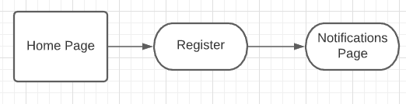

When it comes to registering an account on our web app, it will be as intuitive as any other website and it should not be very difficult, they will just need to fill out specific mandatory fields as well as being approved by our web app that he is working for us and will be able to start working with patients. In the notifications page, that is each PT will be able to see the most recent notifications whether a patient has chosen them as well as be notified whether a patient hasn’t completed all of their exercises or not.

**Uploading Content**

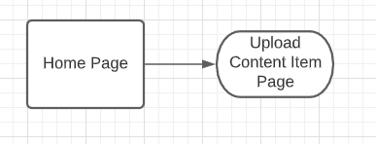

This flowchart is as simple as it gets to uploading content items onto the PT’s cloud library. As soon as the PT is done with editing specific contents of the content item, they can hit “Upload” and from there the PT is able to assign the videos to patients right away.

**Viewing Patient Report & Assigning Content Items**

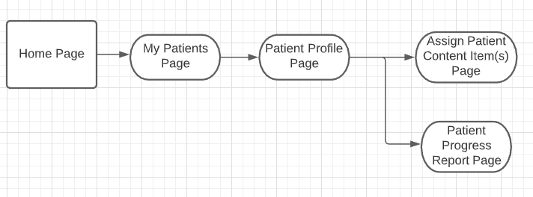

Here is the flowchart in which both the Assigning Content Page and Patient Progress Report Page are in the same area of the Patient Profile Page. This makes it easier to get to the different features.

**UI Mockups**

**Home Page**

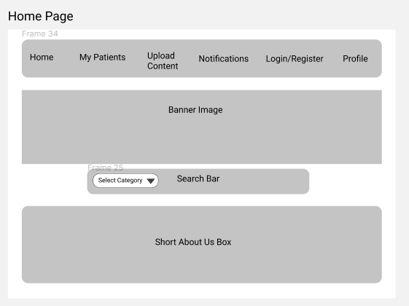

This is a rough estimate of what we want our home page to look like for our PTs. It’s easy enough to look at and not too clutterly like some of the other PT websites we’ve seen.

**Search Page**

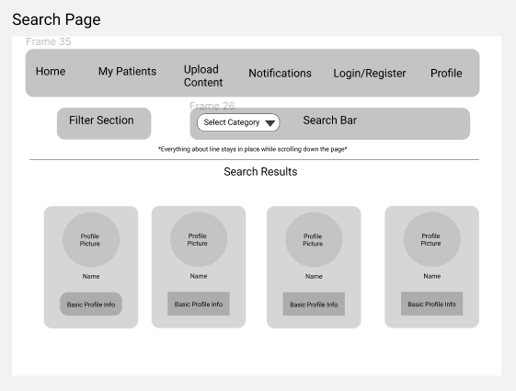

This is our Search Page which can also be filtered out to search for both content items as well as patients and those patients can be people that are not assigned to the PT. The page will be scrollable to see further results as well.

**Upload Content Item Page**

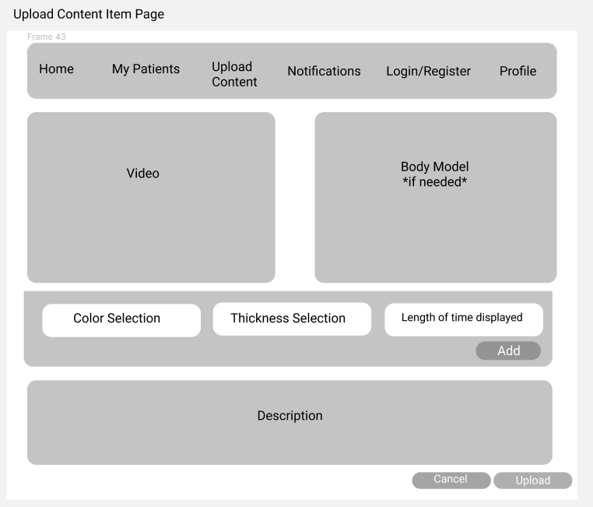

This is where we can edit the information for each content item we upload. The PT will have the option of including a Body Model if needed, bar in the middle lets the PT select the properties of the drawing they can make on the video and lastly a short description of what the purpose of the content item is for.

**Patient Progress Report**

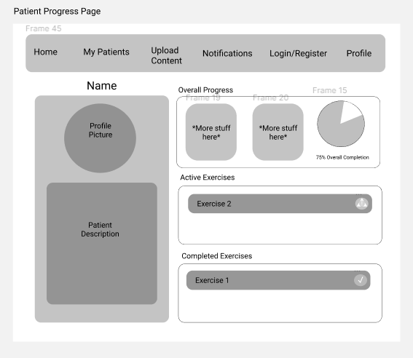

On the Patient’s profile, we will be able to view the overall progress as well as more specific progress reports. We will be able to see what exercises they have or have not completed. This goes with our UI design in keeping everything easy to scroll through as well as using color coding to make things more intuitive.

**Profile Page**

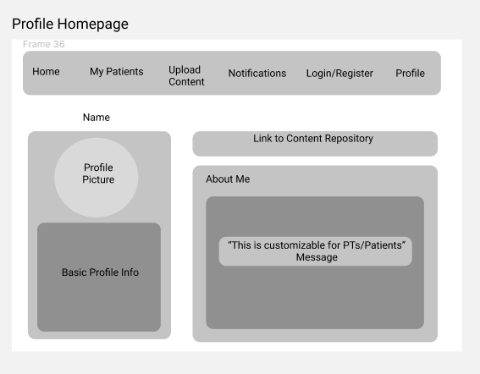

On this page, we will have the main description of the patient on the left and on the right there will be a link to assign content items repository and an “About Me” section which the patient can edit at any time.

**Assigning Content Page**

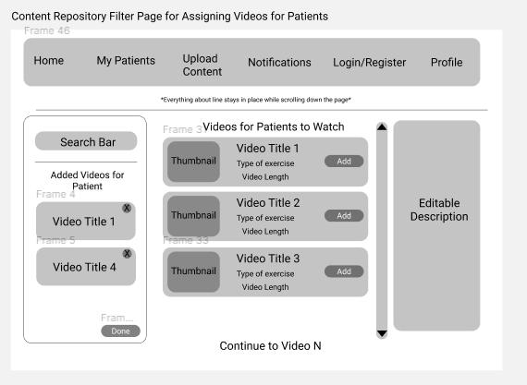

We will have a list of added content items on the left side to differentiate what we are assigning and searching for. There will also be a search bar on the left to make less clutter in the middle. In the middle we will have a downward/upwards scrollable list of the different content items the PT has uploaded and on the right side it will display some description about the video that has been selected.

***4. High Level Architecture, Database Organization***

Our current database design contains 9 tables (although we may add more as functionality increases). These tables are: PhysicalTherapist, Patient, Category, PTVideo, PatientVideo, bodyDiagram, Ping, Report and Post. Variables to be displayed to the screen is designated as (displayed), this is not part of the name.

The PhysicalTherapist table contains: ptID, firstName(displayed), lastName(displayed), email(displayed), password, bio (displayed for profile), tags, pings(displayed), and registrationDate.

The Patient table contains patientID (or pID), firstName(displayed), lastName(displayed), email(displayed), password, bio (displayed for profile), pings, age(displayed), ptID (for their assigned PT) and registrationDate(displayed).

The Category table is used for tags and searches, and contains a categoryID, and a categoryName(displayed) in plain text for displaying.

The PTVideo table is for all things relating to an uploaded PT profile’s video content, including the variables videoID, videoTitle(displayed), videoSize, userUploadID, description(displayed), uploadDate(displayed), and categoryID.

The PatientVideo table is for all things relating to an uploaded and sent Patient’s video content, including the variables videoID, videoTitle(displayed), videoSize, userUploadID, description(displayed), uploadDate(displayed), and categoryID.

The BodyDiagram table relates to the list of body models with specifically lit parts that we will be attaching to posts. It contains variables for modelID, description, patientID, ptID, and a list of all areas on the body we plan to make displayable and tailored to (ankle, knee, back, shoulder, elbow, wrist, upper/lower arm, glute, thigh, calves, neck, core, chest).

The Ping table is for ping notifications and their relevant data, and contains variables for recipient, relevantContent, description(displayed), tags, and position (for order in the list of pings).

The Report table contains relevant information to reports and their generation, such as frequency, activities activitiesStart, activitiesEnd, totalTime, Patient, and PhysicalTherapist.

The Post table is for content posts,and contains all relevant information to what they contain and what they require, containing variables for postID, postName(displayed), description(displayed), tags, patientID, and videoID.

Regarding the functional requirements, the vast majority of our implementation is to be built around a tag system. As seen above, almost every single data table has tags, or a categoryID, which will allow these terms specifically to be searchable, both by users, and within the back end itself. However, for simpler searches on the back end, these tags won’t quite be enough, so we planned ahead, and assign most everything an ID key, which should be easily searchable through an index.

We’re very likely to expand this, once development on the chat features begins in earnest, as well as the streaming features begin.

Some Questions:

***How to search the exercise plan for a particular patient for a given duration (for a specific date or for a specific week)?***

As an upload date is uploaded, as well as a Patient’s ID, a tag can be auto-generated for patient names, and then, using our search feature, plans can be searched for by name, and the most recent uploads should come up first, in descending order, with a displayed upload date. If this isn’t sufficient, we may add a customizable termination date as well, and make these dates, also, both tags.

***How to search the progress (video, text) uploaded by a particular patient?***When a patient uploads progress reports, this should generate a ping that is automatically sent to the PT as per their ping settings. This video should, as well, be uploaded to the *Patient’s* content repository, a searchable index of updates easily accessible from their profile and private to their PT, in the case that the notification has to be revisited after being cleared.

***How to search all the activities of a PT (responding to questions, viewing videos, reading profile, writing notes) to a particular patient. Each activity should be displayed with time and duration (e.g.. Oct 2 10:00 ~ Oct 2 10:05, 5 mins)?***

Anytime these activities are performed, a link to a report should be generated and indexed by that Patient’s ID. This report should have it’s activities activitiesStart, and activitiesEnd updated accordingly, using the time when the activity started, and the time that the activity ended.

***5. High Level UML Diagrams***

These are basic diagrams of how the majority of our systems are associated, and interact with each other as is. Data types have been omitted for these examples.

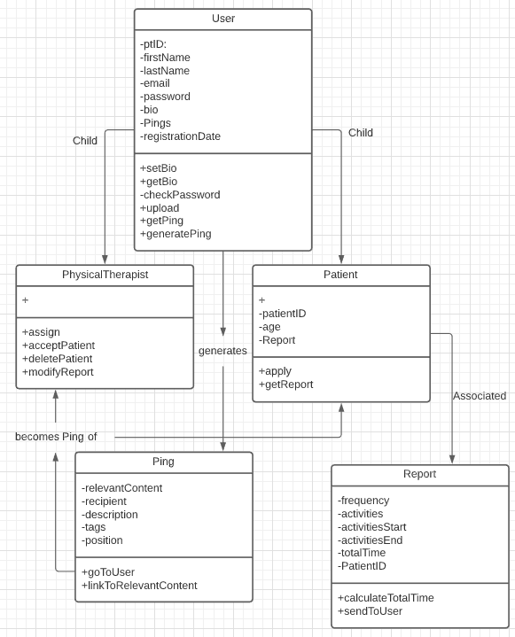

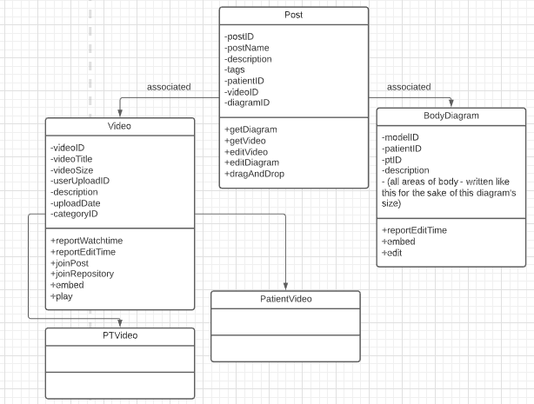

***6. Key Risks for Project***

Skills:  
I believe that the risks involving skills are fairly large, as many of us are very inexperienced in this field, and have never worked on a project of this scale before. The entire project, for a few of us, has seemed rather daunting, and we’ve been scared regarding our ability to work within our stack for some time.  
  
To fix this issue, our scrum leader has been assigned to preparing and finding material that can teach us more about how to develop in this environment, with these kinds of technologies. So far, we’ve put a good amount of time into studying the front end work, and in coming weeks will likely shift our focus to back-end work, to some extent, working with tutorials on Node and Postgres.

Schedule:  
So far, I’ve been unable to identify scheduling risks. Our group is exceptional at coming through to meet even at points which it is not predefined. We’ve rather synergistic schedules, in all honesty.  
  
Technical:  
Our initial weeks were spent getting all of our group familiar with the technical aspects of meeting and developing, so I foresee no risks here either.

Teamwork:  
Our team is somewhat prone to waiting to get things done, and putting in less effort than should be put in until the day-of. This issue has persisted somewhat, and I don’t exactly believe it to be related to morale.  
  
My solution to this issue is to, as a team leader, either increase the amount of times we meet, or enforce stricter deadlines for modules being turned in. I don’t view this to be a particularly extreme issue yet, but I would like to eliminate it before it becomes one.   
  
Legal:  
All of our software is free to use, and free to implement, so I see no issues here (unless Google decides to charge us more for our trial time on our Cloud machine, which they’ve already tried to do once, but we already fixed.)

***7. Project Management***

The majority of this milestone was broken down based on the Front End and Back End teams. A few of us got together with the Front end Lead to get some designs and diagrams created for the future implementation of the webpages, and allowed the back end team to start working on their end independently from us, coming together to centralize the information so we could write this document. We met twice a week at least, for over an hour at a time, and spent the entire time planning our sessions and making sure we were on track while working collaboratively. The majority of our planning and work was done during these sessions, though we continue to be in constant communication over the program Discord, which we all make good use of.   
  
We intend to continue making use of these sessions and discord, but to begin making the actual work get done outside of them, using the sessions as touchstones for us to come together and reach a consensus on issues that arise. We believe this will allow us to achieve more, and hold ourselves to an even higher standard than we’ve already achieved.